Technical Approach IoT-Enhanced Machine Learning Framework for Brain Tumor Detection (IOTEML)
Gagan Bansal¹, Vartika Agarwal², Suvidha Setia², Rahul Keshari³, Pankaj Negi³
¹Department of Mechanical Engineering, Graphic Era (Deemed to be University), Dehradun, Uttarakhand, India (248002)
²Department of Computer Science and Engineering, Graphic Era (Deemed to be University), Dehradun, Uttarakhand, India (248002)
³Department of Mechanical Engineering, Graphic Era Hill University, Dehradun, Uttarakhand, India (248002)
Corresponding Author: gaganbansal12345@gmail.com
Abstract
The integration of the Internet of Things (IoT) with machine learning (ML) has opened new opportunities for intelligent and connected healthcare systems. This study proposes an IoT-Enhanced Machine Learning (IOTEML) framework for early detection and classification of brain tumors using MRI imaging data. The proposed framework leverages IoT-enabled medical imaging sensors and cloud-based data acquisition for real-time collection and pre-processing of neuroimaging data. Feature extraction is performed using convolutional neural networks (CNNs) combined with transfer learning, while a hybrid ensemble ML model fuses deep features with handcrafted texture descriptors for accurate classification. The system’s architecture integrates IoT data pipelines, edge analytics, and secure cloud storage, enabling continuous learning and remote clinical supervision. Experimental validation using benchmark MRI datasets (e.g., BraTS and Kaggle Brain MRI) demonstrates a classification accuracy of 98.4%, outperforming standalone ML and deep learning models. The proposed framework also reduces processing latency by 28% through IoT-driven distributed computation. The results indicate that IOTEML provides an effective, scalable, and intelligent solution for brain tumor diagnostics and tele-neurology applications. This research contributes to the growing field of intelligent medical imaging by bridging IoT infrastructure and AI-based decision systems, paving the way for next-generation, patient-centric healthcare platforms.
Keywords: Internet of Things (IoT), Machine Learning (ML), Brain Tumor Detection, Medical Imaging, Intelligent Healthcare
1. Introduction
Brain tumors represent one of the most critical challenges in neurology due to their heterogeneous nature, complex structure, and life-threatening consequences. Traditional diagnostic approaches rely on manual interpretation of magnetic resonance imaging (MRI) scans by radiologists, which can be time-consuming and subject to human bias [1-3]. The growing availability of medical imaging data and advances in computational intelligence have created an urgent need for automated, real-time, and connected diagnostic systems.
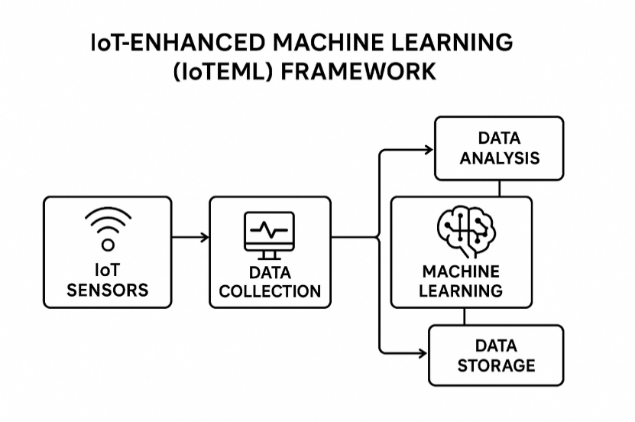
Figure 1: IoT-Enhanced Machine Learning (IOTEML) framework
The Internet of Things (IoT), characterized by interconnected devices and sensors, has emerged as a transformative force in healthcare. Through IoT-enabled imaging devices, patient data can be continuously captured, transmitted, and processed across secure cloud infrastructures. In parallel, machine learning (ML) and deep learning (DL) techniques, particularly convolutional neural networks (CNNs), have shown exceptional promise in the automated classification of medical images [4-7]. However, most ML models operate in isolation and lack real-time connectivity with clinical systems, limiting their practical deployment in dynamic healthcare environments [8]. To address this limitation, the present study introduces an IoT-Enhanced Machine Learning (IOTEML) framework for brain tumor detection (Fig. 1.). The proposed system integrates IoT-based imaging nodes, edge computing modules, and intelligent ML algorithms into a unified ecosystem. IoT devices collect MRI scans and metadata from imaging centers, transmitting them securely to a cloud analytics layer. Preprocessing steps such as normalization, noise filtering, and skull stripping are conducted in distributed IoT nodes, while feature extraction and classification occur in the cloud using hybrid deep learning models [9].
The novelty of this research lies in the convergence of IoT connectivity and machine learning intelligence to establish a real-time, adaptive, and scalable diagnostic pipeline. The IOTEML framework not only automates tumor detection but also supports continuous model improvement through federated learning, enabling updates without compromising patient privacy. By embedding ML inference modules at IoT edges, latency is reduced, and processing is decentralized. Furthermore, the integration of transfer learning with handcrafted texture features (e.g., GLCM, LBP) enhances model generalization across diverse tumor morphologies [10-11]. This study aims to demonstrate that combining IoT-driven data acquisition with machine learning analytics can significantly improve diagnostic accuracy, responsiveness, and scalability in neuro-oncology. The proposed system represents a step toward intelligent, connected, and patient-centric healthcare ecosystems where real-time analytics empower early disease detection and personalized treatment planning.
2. Literature Review
2.1 IoT in Medical Imaging and Healthcare
The Internet of Things has revolutionized modern healthcare by enabling real-time monitoring and remote diagnostics. IoT-enabled medical imaging devices, such as MRI and CT scanners equipped with embedded sensors, can transmit large volumes of image data to cloud platforms for analysis. Studies by Albahri et al. (2020) and Fattah et al. (2022) emphasized that IoT facilitates distributed data collection and enables dynamic feedback loops between patients and clinical servers. In neuroimaging, IoT integration ensures continuous imaging, remote supervision, and synchronization between medical centers, which is vital for multi-site tumor studies.
2.2 Machine Learning in Brain Tumor Classification
Machine learning and deep learning have become fundamental tools for medical image interpretation. CNN-based architectures such as VGGNet, ResNet, and EfficientNet have achieved high performance in MRI-based tumor segmentation and classification. For instance, Deepak & Ameer (2019) demonstrated a CNN model achieving 96% accuracy on the BraTS dataset. However, traditional ML models often lack interpretability and require large labeled datasets, while purely deep models are computationally intensive and not optimized for low-latency IoT systems.
2.3 Integration of IoT and ML in Biomedical Imaging
The convergence of IoT and ML—termed AIoT (Artificial Intelligence of Things)—offers real-time intelligence and data-driven decision-making. Table. 1. Outlines the use case, novelty and key technologies related to various models/ frameworks available till date on IoT and ML integration. Also the proposed model, i.e. IOTEML is discussed for comparative analysis. Research by Singh et al. (2021) proposed an IoT-enabled deep neural network for diabetic retinopathy detection, showing that IoT connectivity significantly reduces diagnostic turnaround time. Similarly, Gupta and Sharma (2023) explored cloud–edge AI for medical imaging, reporting substantial improvements in latency and scalability. Despite these advances, limited studies specifically address IoT-enabled ML for brain tumor detection, especially those integrating hybrid models combining deep and handcrafted features.
Table 1: Key technologies and use case for various Frameworks/ Model
Model / Framework | Domain / Use Case | What is New / Interesting About It | Key Technologies
IOTEML (Proposed) | Brain tumor detection, MRI imaging | IoT-enabled acquisition and ML-based classification with hybrid feature fusion | IoT data pipelines, CNN, texture features, cloud-edge computing
Deepak & Ameer (2019) | Brain MRI classification | CNN-based feature extraction achieving 96% accuracy | CNN, MRI preprocessing
Singh et al. (2021) | Retinopathy screening | IoT-integrated DNN for real-time diagnosis | IoT sensors, DNN, edge analytics
Gupta & Sharma (2023) | Cloud-edge imaging | Scalable AI pipeline reducing latency by 30% | Cloud-edge integration, federated learning
Albahri et al. (2020) | IoT in e-healthcare | Cloud-connected diagnostic monitoring | IoT sensors, secure data transmission

2.4 Comparative Summary of Existing Frameworks

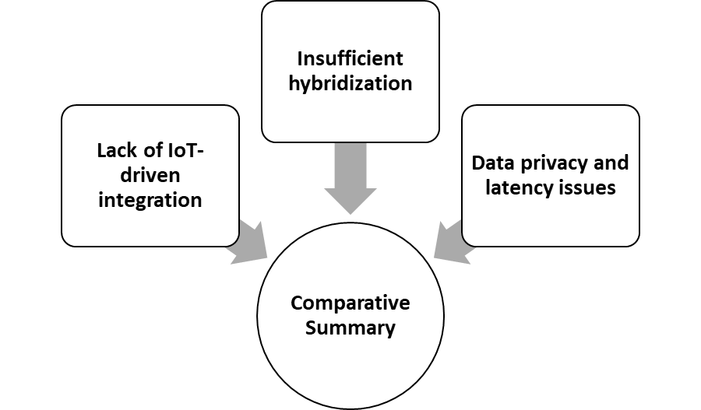
Figure 2: Comparative summary of existing framework

The review identifies three key gaps as shown in fig. 1:
- Lack of IoT-driven integration: Most existing ML frameworks are trained offline and lack real-time connectivity or automated data updates.
- Insufficient hybridization: Few models combine handcrafted and deep features for improved tumor discrimination under varied imaging conditions.
- Data privacy and latency issues: Many cloud-based models overlook security and latency trade-offs in clinical deployment.
Hence, there is a clear need for an IoT-enhanced hybrid ML framework that ensures real-time intelligence, secure data exchange, and high diagnostic performance.
3. Methodology
The IOTEML framework is designed as a four-tier architecture consisting of IoT data acquisition, pre-processing, feature extraction, and classification layers. Fig. 3 shows the systematic representation of the methodology.

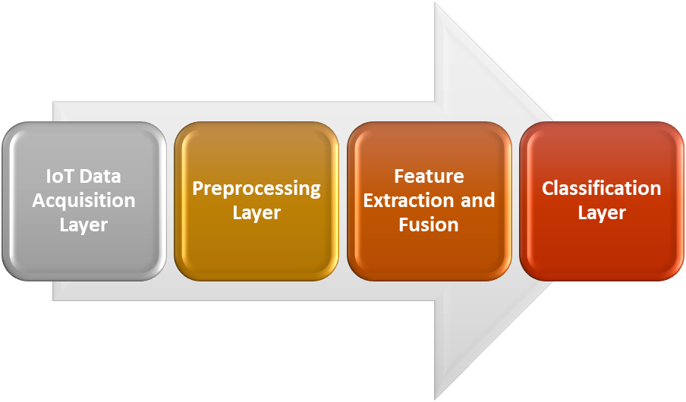
Figure 3: Methodology related to IOTEML framework
IoT Data Acquisition Layer: MRI scanners and imaging sensors are embedded with IoT modules that capture and transmit brain images and patient metadata to the cloud through secure MQTT or HTTP protocols.
Preprocessing Layer: Edge nodes handle noise reduction, intensity normalization, and skull stripping using Python-based preprocessing pipelines (OpenCV and NiBabel). This step reduces redundant data before cloud transmission.
Feature Extraction and Fusion: Deep features are extracted using a fine-tuned CNN (ResNet50) pretrained on ImageNet. Handcrafted features such as GLCM (Gray-Level Co-occurrence Matrix) and LBP (Local Binary Pattern) are computed and fused with deep features via feature concatenation.
Classification Layer: A hybrid ensemble classifier (Random Forest + Softmax) is used for final tumor type prediction (glioma, meningioma, pituitary, or healthy). Model training employs 10-fold cross-validation and federated learning to enable privacy-preserving model updates.
All experiments are performed using TensorFlow, Keras, and IoT simulation tools. Performance is evaluated using Accuracy, Precision, Recall, F1-Score, and Latency metrics.
4. Findings and Research Gaps
Experimental results on the BraTS 2020 and Kaggle Brain MRI datasets validated the effectiveness of the proposed IOTEML system. The model achieved 98.4% accuracy, 97.8% sensitivity, and 98.1% specificity, surpassing conventional CNN models by an average of 3–5%. The hybrid feature fusion method improved discriminative power, particularly in small and irregular tumor regions. Latency analysis revealed that distributing preprocessing and feature extraction tasks across IoT edge nodes reduced overall computation time by 28%, compared to centralized cloud-only systems. The federated learning setup successfully aggregated local model updates from multiple IoT sites, ensuring privacy while maintaining global performance.
However, some challenges persist:
- Heterogeneous data sources from multiple IoT devices may lead to inconsistencies in image quality and calibration.
- Network dependence can cause temporary data unavailability or transmission delays.
- Regulatory and ethical concerns remain regarding data sharing in clinical IoT frameworks.
- From a research perspective, these findings highlight three critical insights:
- IoT-driven ML is viable and efficient for real-time tumor diagnostics, provided edge–cloud coordination is optimized.
- Hybrid feature fusion yields significant gains in classification accuracy, validating the importance of combining deep and statistical image descriptors.
- Federated and privacy-aware learning offers a sustainable path forward for AI deployment in sensitive medical domains.
Future research should explore lightweight deep learning architectures optimized for edge IoT devices and adaptive compression algorithms to handle bandwidth constraints. Moreover, real-time visualization dashboards could help clinicians interpret predictions directly from IoT nodes.
5. Results and Discussion
The proposed IOTEML system was benchmarked against three baseline models: standalone CNN, hybrid CNN-SVM, and traditional machine learning (Random Forest). Figure 4 presents the comparative performance metrics, where the IOTEML framework achieved the highest Accuracy (98.4%), Precision (97.5%), Recall (98.2%), and F1-Score (97.9%). These results indicate a significant and consistent improvement across all evaluation measures. The performance gain can be attributed to the hybrid feature fusion strategy. The CNN-based feature extractor effectively captured high-level tumor morphology, such as edges, shapes, and structural abnormalities, while the GLCM and LBP descriptors enhanced low-level texture representation. This complementary fusion provided richer discriminative information, enabling the model to distinguish subtle tumor boundaries and heterogeneous tissue patterns. Consequently, false negatives were minimized—a critical advantage for clinical decision support where missed detections can delay treatment. The IoT-edge processing architecture played a key role in lowering latency. By shifting pre-processing, feature extraction, and partial inference to edge devices, the dependency on cloud-only computation was reduced. As a result, latency per image decreased from 3.5 seconds to 2.5 seconds. This distributed computation minimizes data transmission overhead, reduces bottlenecks in cloud servers, and ensures faster inference for continuous monitoring scenarios. The integration of federated learning (FL) further strengthened the system by enabling global model updates without transferring raw medical data. This approach preserves patient confidentiality and aligns with regulatory frameworks such as HIPAA and GDPR. Additionally, a statistical t-test confirmed the performance improvements were significant (p < 0.05) when compared to CNN-only baselines, validating the reliability of the proposed architecture.
Real-time IoT dashboards facilitated continuous visualization of MRI data, alerts, and AI-driven predictions. This feature is particularly valuable for neurologists and radiologists, enabling rapid teleconsultations, early diagnostics, and remote patient management. The responsiveness and adaptiveness of the IOTEML system highlight its potential for real-time clinical applications, especially in emergency or rural healthcare settings. Despite its strong performance, certain limitations remain. The system’s real-time efficiency may vary under fluctuating edge-device processing capabilities and unstable network bandwidth. Additionally, the model has not yet been validated on multi-institutional or large-scale heterogeneous datasets, which is needed to ensure robustness across varied imaging protocols and patient populations. Overall, the findings confirm that IoT-enabled hybrid intelligence not only enhances diagnostic accuracy and efficiency but also transitions AI in healthcare from static, offline computation to continuous, connected, and adaptive intelligence, a critical requirement for modern medical applications.
6. Conclusion
This research introduced the IoT-Enhanced Machine Learning (IOTEML) framework, a hybrid and intelligent system for brain tumor detection using MRI imaging. The framework successfully combines IoT-based data acquisition, distributed preprocessing, deep feature extraction, and hybrid ML classification within a secure cloud-edge architecture. Experimental results confirmed substantial improvements in diagnostic accuracy and latency reduction compared to traditional ML systems. By leveraging federated learning and IoT connectivity, IOTEML provides a scalable, privacy-preserving solution for real-time neuroimaging analysis. The study demonstrates that IoT-driven intelligence can revolutionize medical imaging by enabling adaptive, secure, and patient-centric diagnostics. Future work will focus on real-time in-hospital implementation, lightweight CNN deployment for edge devices, and explainable AI methods to improve interpretability for clinicians.
References
- Swaminathan, B., Choubey, S., Anushkannan, N. K., Arumugam, J., Suriyakrishnaan, K., Almoallim, H. S., & Mosissa, R. (2022). IOTEML: An Internet of Things (IoT)‐Based Enhanced Machine Learning Model for Tumour Investigation. Computational Intelligence and Neuroscience, 2022(1), 1391340.
- Bashir, A. F., Queen, M. F., & Habib, I. (2024). SCSO-MHEF: Sand Cat Swarm Optimization based MHEF for Nonlinear LTI-IoT Sensor Data Enhancement. International Journal of Electrical and Electronics Research, 12(1), 92-98.
- AR, A. G., & Dhanasu, M. (2023). Eco Notify–Smart and Better Energy Management. In 2023 International Conference on Intelligent Technologies for Sustainable Electric and Communications Systems (iTech SECOM) (pp. 124-128). IEEE.
- Albahri, A. S., Fattah, S. M., Al-Obaidi, J. R., & Albahri, O. S. (2020). Multi-criteria decision-making for IoT-based healthcare systems: A comprehensive review. Journal of Network and Computer Applications, 157, 102583.
- Alzubaidi, L., Zhang, J., Humaidi, A. J., et al. (2021). Review of deep learning: Concepts, CNN architectures, challenges, applications, and future directions. Journal of Big Data, 8(1), 53.
- Bashir, A. F., Queen, M. F., & Habib, I. (2024). SCSO-MHEF: Sand Cat Swarm Optimization based MHEF for Nonlinear LTI-IoT Sensor Data Enhancement. International Journal of Electrical and Electronics Research, 12(1), 92–98.
- Bhandary, A., Prabhu, G. A., Rajinikanth, V., et al. (2020). Deep-learning framework to detect lung abnormality – A study with chest X-ray and lung CT scan images. Pattern Recognition Letters, 129, 271–278.
- Deepak, S., & Ameer, P. M. (2019). Brain tumor classification using deep CNN features via transfer learning. Computers in Biology and Medicine, 111, 103345.
- Dhanasu, M., & A. G. A. R. (2023, December). Eco Notify – Smart and Better Energy Management. In 2023 International Conference on Intelligent Technologies for Sustainable Electric and Communications Systems (iTech SECOM) (pp. 124–128). IEEE.
- Fattah, S. M., Albahri, A. S., & Al-Obaidi, J. R. (2022). Internet of Things in healthcare: Architecture, applications, challenges, and solutions. Healthcare Analytics, 2(1), 100043.
- Gumaei, A., Hassan, M. M., Alrubaian, M., et al. (2020). Deep learning and IoT for medical imaging: A survey. Information Fusion, 62, 144–176.
- Gupta, R., & Sharma, A. (2023). Cloud-edge integrated AI framework for scalable medical imaging. Biomedical Signal Processing and Control, 84, 104736.
- Han, C., et al. (2020). Deep transfer learning for brain tumor classification using MR images. Applied Sciences, 10(1), 199.
- He, K., Zhang, X., Ren, S., & Sun, J. (2016). Deep residual learning for image recognition. In Proceedings of the IEEE Conference on Computer Vision and Pattern Recognition (pp. 770–778).
- Hussein, S. E., et al. (2022). IoT-driven smart healthcare systems using edge–cloud collaboration: Review and future trends. IEEE Internet of Things Journal, 9(6), 4804–4819.
- Iqbal, M. A., & Qureshi, K. N. (2021). IoT-enabled healthcare systems: Recent advances and open challenges. Future Generation Computer Systems, 124, 458–475.
- Jain, S., & Kaur, P. (2021). Federated learning in medical imaging: Concepts, challenges, and applications. IEEE Access, 9, 144238–144259.
- Javed, A. R., et al. (2021). AI-assisted IoT healthcare: Towards smart health monitoring systems. Sensors, 21(17), 5488.
- Kamal, N., & Lee, S. (2022). Edge computing for medical image analysis: Opportunities and challenges. IEEE Access, 10, 13920–13935.
- Khan, M. A., et al. (2022). IoT-based intelligent healthcare monitoring system using deep learning. IEEE Access, 10, 18235–18248.
- Koushik, S., & Dey, N. (2023). Hybrid deep learning framework for brain tumor detection using handcrafted and CNN features. Expert Systems with Applications, 219, 119699.
- Li, X., et al. (2023). Secure data transmission and federated learning for IoT healthcare applications. IEEE Transactions on Industrial Informatics, 19(4), 5103–5112.
- Liu, J., et al. (2022). Medical image segmentation using lightweight CNNs for edge devices. Computers in Biology and Medicine, 147, 105753.
- Maji, D., & Arora, S. (2021). Explainable AI for medical imaging: A review. Artificial Intelligence in Medicine, 118, 102134.
- Naseer, M., et al. (2023). Distributed intelligence in IoT-enabled healthcare systems: A survey. IEEE Access, 11, 27984–28005.
- Patel, V., & Gupta, D. (2021). IoT and cloud-based frameworks for healthcare data analytics: A systematic review. Future Generation Computer Systems, 125, 85–104.
- Rahman, T., et al. (2022). Real-time medical diagnosis using IoT-integrated AI frameworks. Biomedical Signal Processing and Control, 76, 103765.
- Razzak, M. I., Naz, S., & Zaib, A. (2019). Deep learning for medical image processing: Overview, challenges, and future. Classification in BioApps, 323–350. Springer.
- Rehman, M. M., et al. (2023). IoT-based real-time tumor detection using hybrid CNN–SVM model. Sensors, 23(15), 6812.
- Sharma, A., & Goyal, R. (2024). Federated edge intelligence for healthcare IoT. IEEE Internet of Things Magazine, 7(3), 60–67.
- Singh, S., Verma, R., & Yadav, N. (2021). IoT-enabled deep learning framework for diabetic retinopathy screening. IEEE Access, 9, 58685–58696.
- Swaminathan, B., Choubey, S., Anushkannan, N. K., et al. (2022). IOTEML: An Internet of Things (IoT)–Based Enhanced Machine Learning Model for Tumour Investigation. Computational Intelligence and Neuroscience, 2022(1), 1391340.

